To depart or not to depart…
That is the question

Report by Teatralie (CZ)

We joined the project as an organization working with artistic means, primarily within the framework of our theatre activity with people with learning difficulties. In addition to theatre as art and a specific way of aesthetic communication we also draw from theatre as a therapeutic and educational tool. That means a field of creativity leading to a piece of art on one side and a reflection of creative process to improve skills and knowledge on the other.
This largely determined our role within the entire project and we became responsible for a supervision of creative and artistic process via theatre principles and tools.
Thus this report as our final output is a personal reflection of the creative process during the whole project. Therefore, let us frame it from the point of view of the Aristotle's drama structure, consisting of five phases, which is coincidentally a number corresponding with a number of our live meetings. Those drama phases are: exposition, rising action, climax, falling action and resolution.
This time we are not going to follow narrative of the story and development of individual characters but the main aspects that were influencing each stage and led to certain knowledge enabling a step to another level.

- EXPOSITION

Exposition is an introduction to the story, setting up the scene.

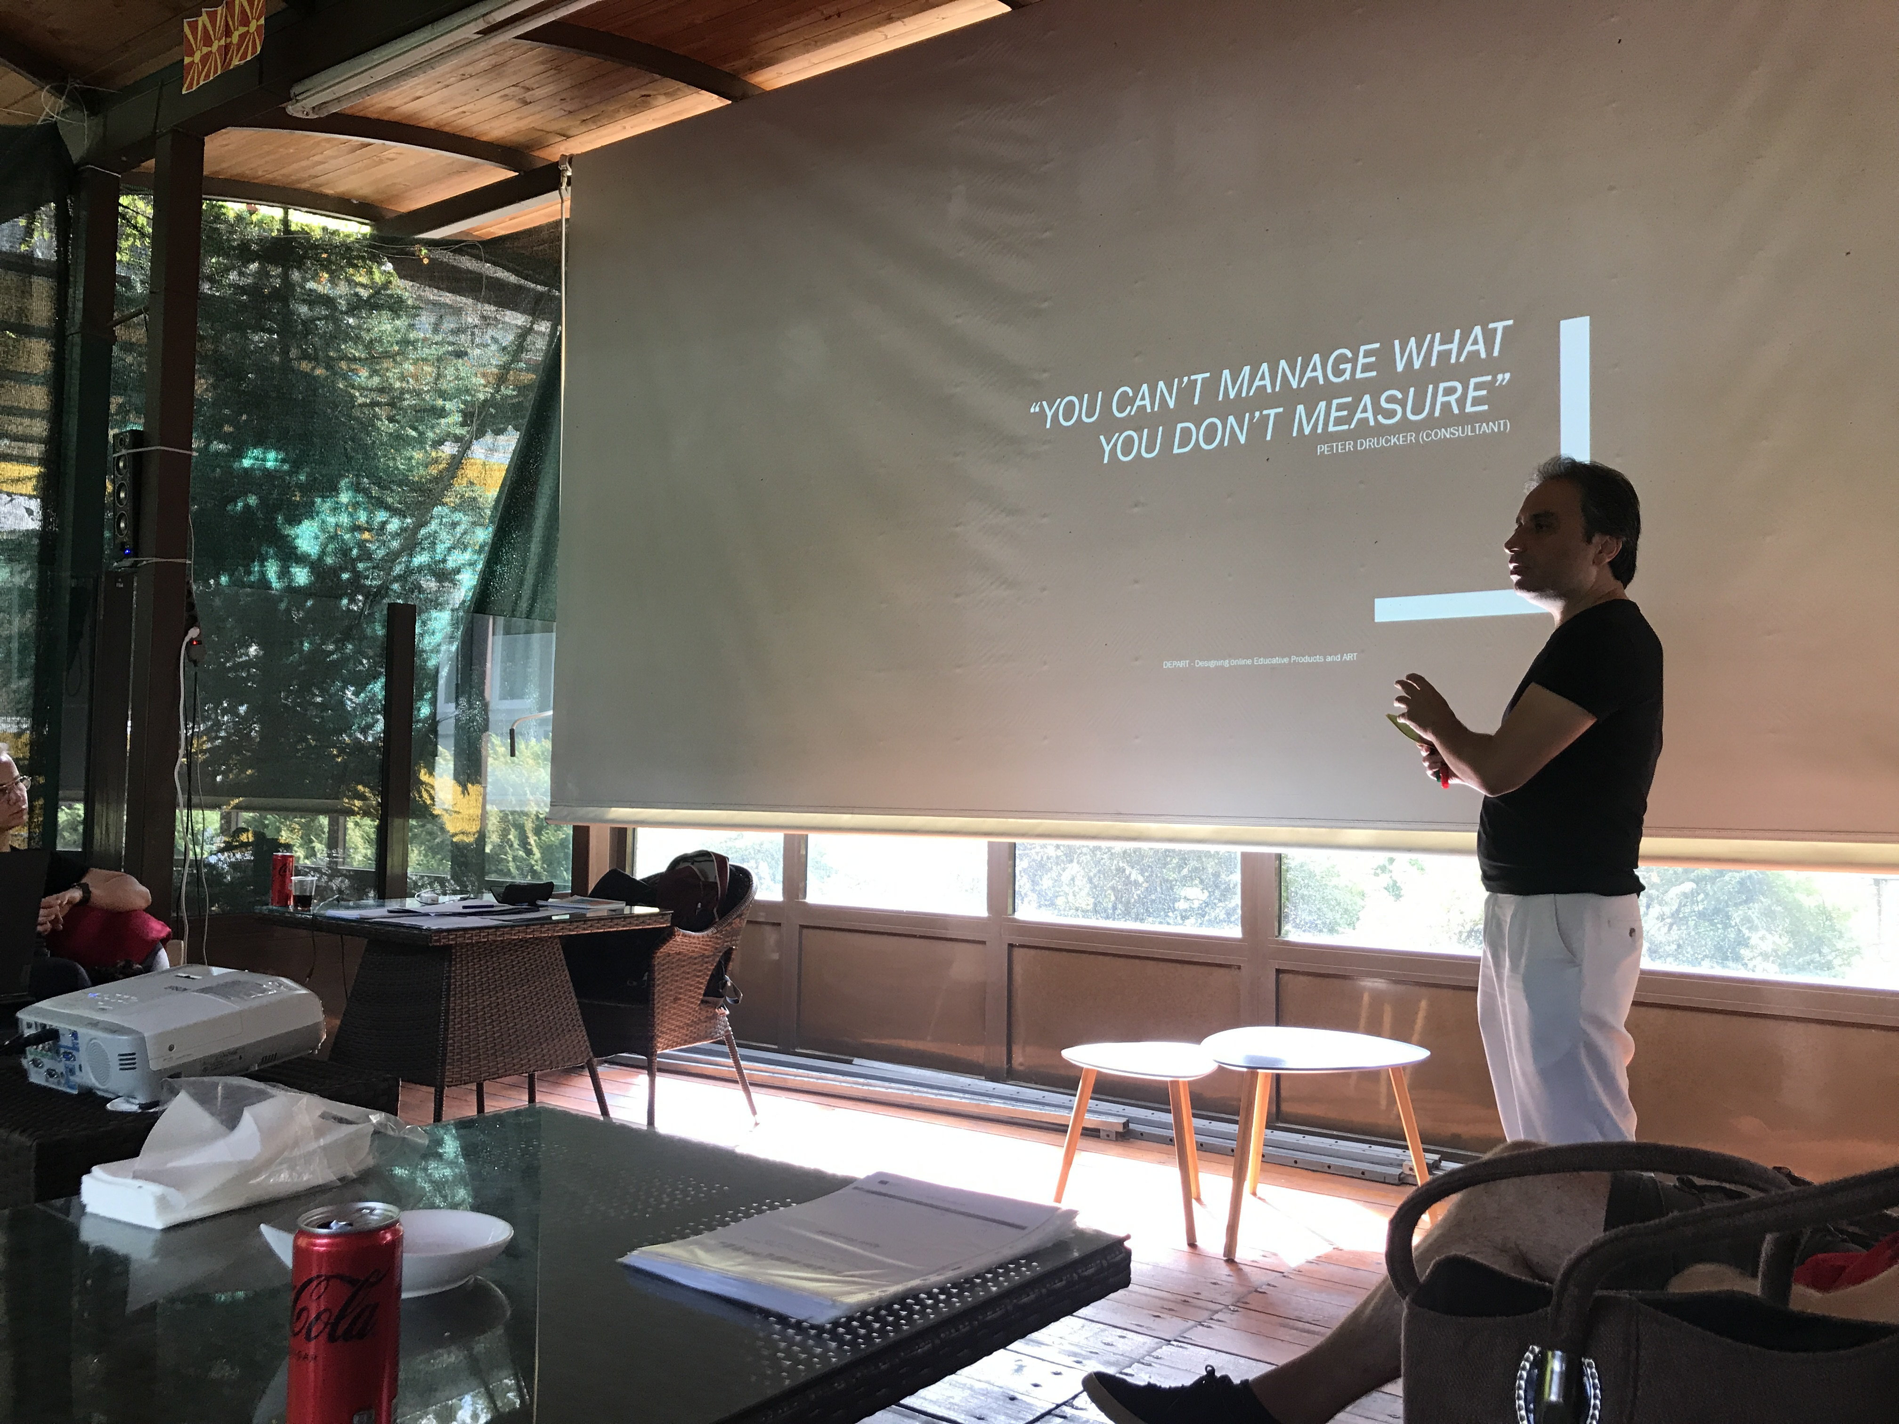
First live meeting in Skopje. Performers and the audience aka participants of the meeting are worming up tasting first emotions and feelings of expectation, curiosity, ambition, hesitation, dreaming, tension and first doubts. These were first and very important means of communication leading to many debates, few creative attempts and first trials to define our task, especially an intriguing but mostly disturbing question: what is the purpose of this project?
And to first conclusions based on live experience:
- Online space increases the possibility of misinterpretation and loss of essential information. It means that it requires different ways and means than live teaching or presentation, as well as those in written textbooks. We might find a certain parallel with the difference between film and theatre acting.
- Circumstances of the recipient should be taken into account otherwise the context of why and what is being said is going to be lost.
- It seems natural to get inspired online to create an online product. But! According to tons of examples this tendency leads very often to a repetition, to present what has already been presented, formally or in terms of content, so that the final result is just a mere copy.

- RISING ACTION

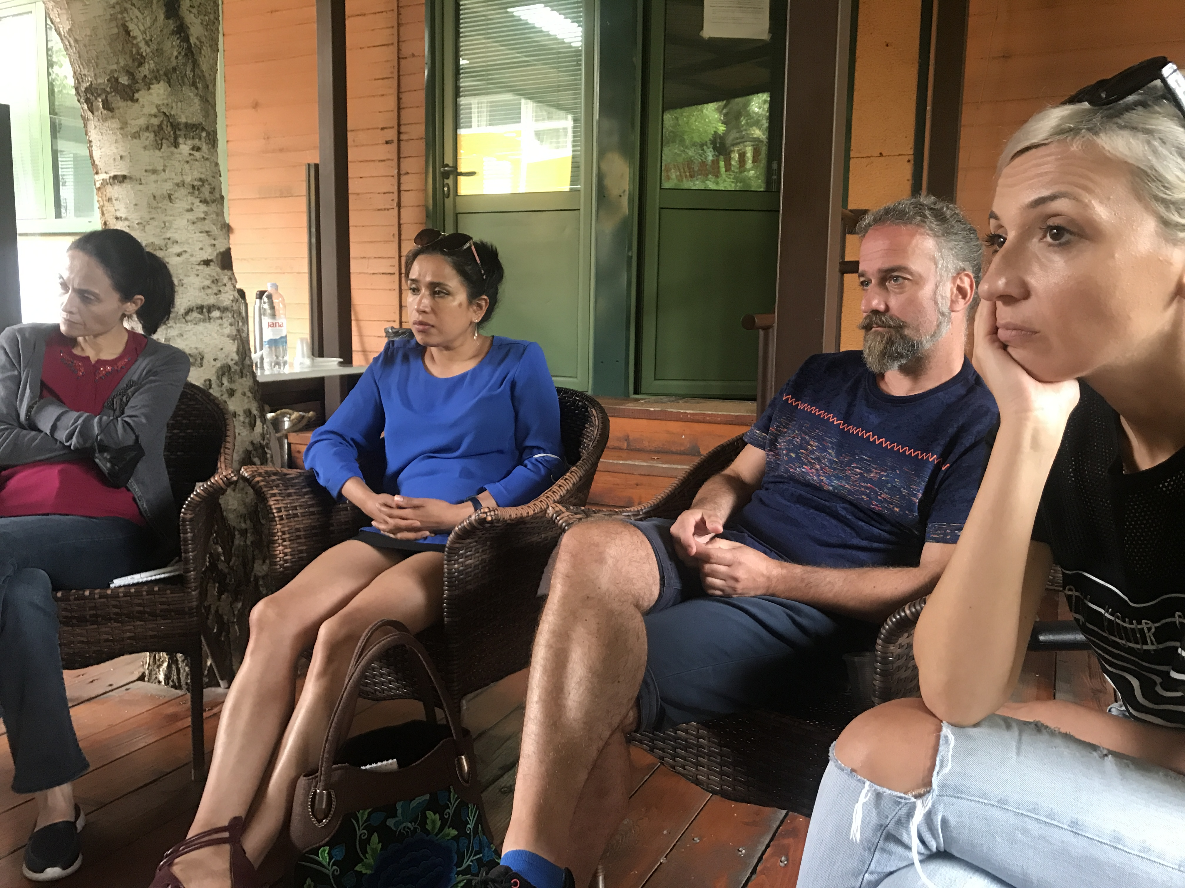
Rising action phase in drama often begins with conflict (which is in some concepts a separate phase). It covers the conflict and following events leading to the eventual climax or turning point of the story.
Second live meeting in Aydin. The track, the story we began, starts to be complicated followed by shared feelings of getting or being lost, chaos and misunderstanding, rousing effort to search for the direction, map possibilities, and finally to sense the contours.
At this level we learned that:
- Less information is more. It needs no comment.
- Less ambition is more. Being too ambitious can mislead creators from the original idea or waste the creative energy.
- Form x content. Content and form are equally important for presenting any idea in the online space.
- Joke. It is always advantageous if we approach creation with a certain exaggeration and humour. On the other hand, everything in moderation applies here too.
- Don’t be literal. Leave some space for fantasy.
- Use association, don’t get satisfied with the first idea.
- When you get overwhelmed with your own need, it breaks connection with the target group and discourages potential recipients. A careful study of the target group of the product is inevitable.

- CLIMAX

Climax is a culmination or a turning point of the story.

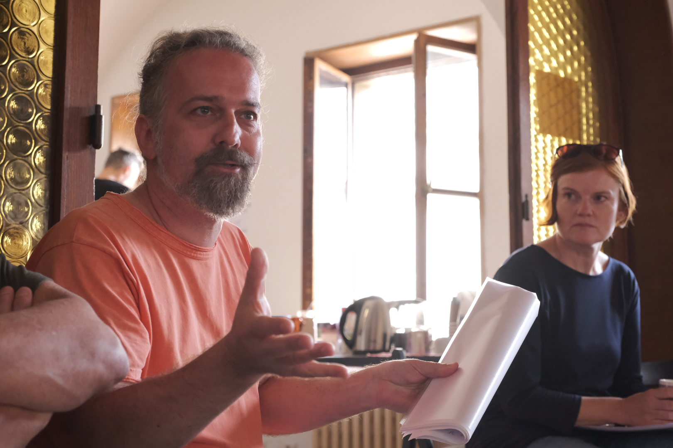
Third live meeting in Prague. Our hosting turn focused on laying out the track, exploration of the tools, spark of creativity, discovering team forces and clarifying team roles. We combine art work with interactive techniques and lots of reflective debates and other ways of feedback.

Examples of techniques:
I. Object game: combination of self-presentation, presentation, role play, improvisation.
Rules:
- pick an object out of group of the objects
- in couples: introducing to each other through the object
- exchange of the objects and change of the partner
- introducing to each other through the newly obtained object
- another exchange and the same principle as in c) and d) – several times
- after last exchange the group gets back together, everybody introduces him/hreselef to the group through the lately obtained object, the group can see the shift of the information from the original

The aim, focus:
presentation, self-presentation, improvisation, disruption of well-established concepts, development of playfulness and creativity also through challenge, non-violent role playing, exploration of the comfort zone by crossing it, new form of presentation and self-presentation, presentation through an object - memorability, emphasis of meaning.

II. Six part story method: Creation of a story through a structure:
- hero
- his/her challenge/goal/destination
- meeting an enemy/opponent
- meeting a helper
- fight/confrontation
- end
The aim: creating a story based on a projective or personal material

III. Comic book: combination of artwork, narration, enacting
Rules:
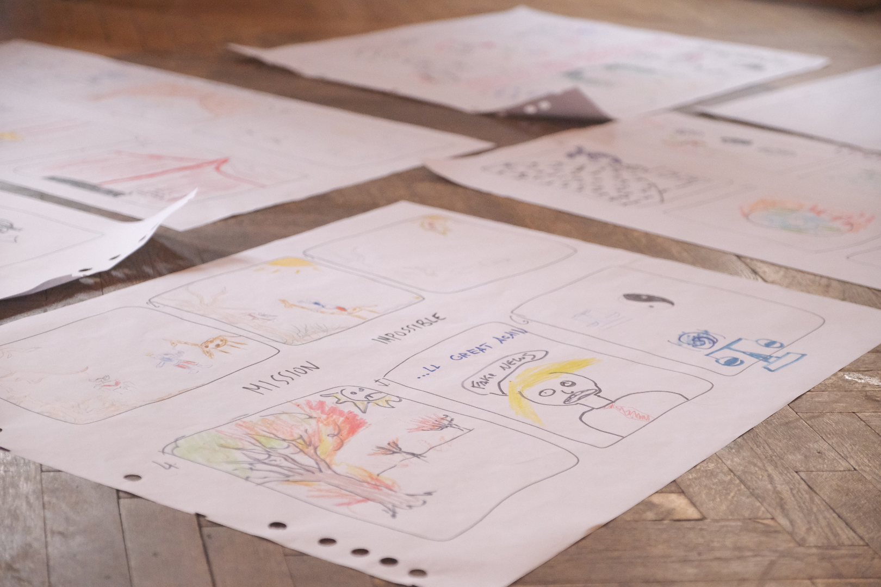
- individual: using an individual hero created in previous game
- sharing in couples or small groups
- creating a new story based on all heroes and original stories together
- drawing a beginning of a strip on the poster, frame 1
- switch to another poster, frame 2 = work with another story
- switch to another, frame 3 = another story etc…
- back to the original poster, frame 6 = end of the original story
- name and presentation in front of the group (dance, song etc.)
The aim, focus:
working with a personal theme and using it/transcending it into the creation of a story, sharing personal contents and creating based on them - using the emotional level - potential for using the viewer's emotions, going beyond established conventions, association training, overcoming challenges, frustration, the ability to let go of control and performance, process trust, collaboration, team trust, fun, relaxation, and at the same time focus on the essentials.

Discovery:
- The importance of reflection, or feedback from an unbiased environment - throughout the entire process of creation.
- Creativity - follow the process, necessity of space and time, observation of the development, necessity of being inside the process and also step back.
- Don't give up the craft. It is important not to give up on the craft side of things (technically and artistically).
- Cross the border.
- Reflecting group dynamics is an essential part of team work.

- FALLING ACTION

Falling action is the beginning of the end. It includes all of the events and everything that happens as a result of the climax, including wrapping-up of plot points, questions being answered, and character development.
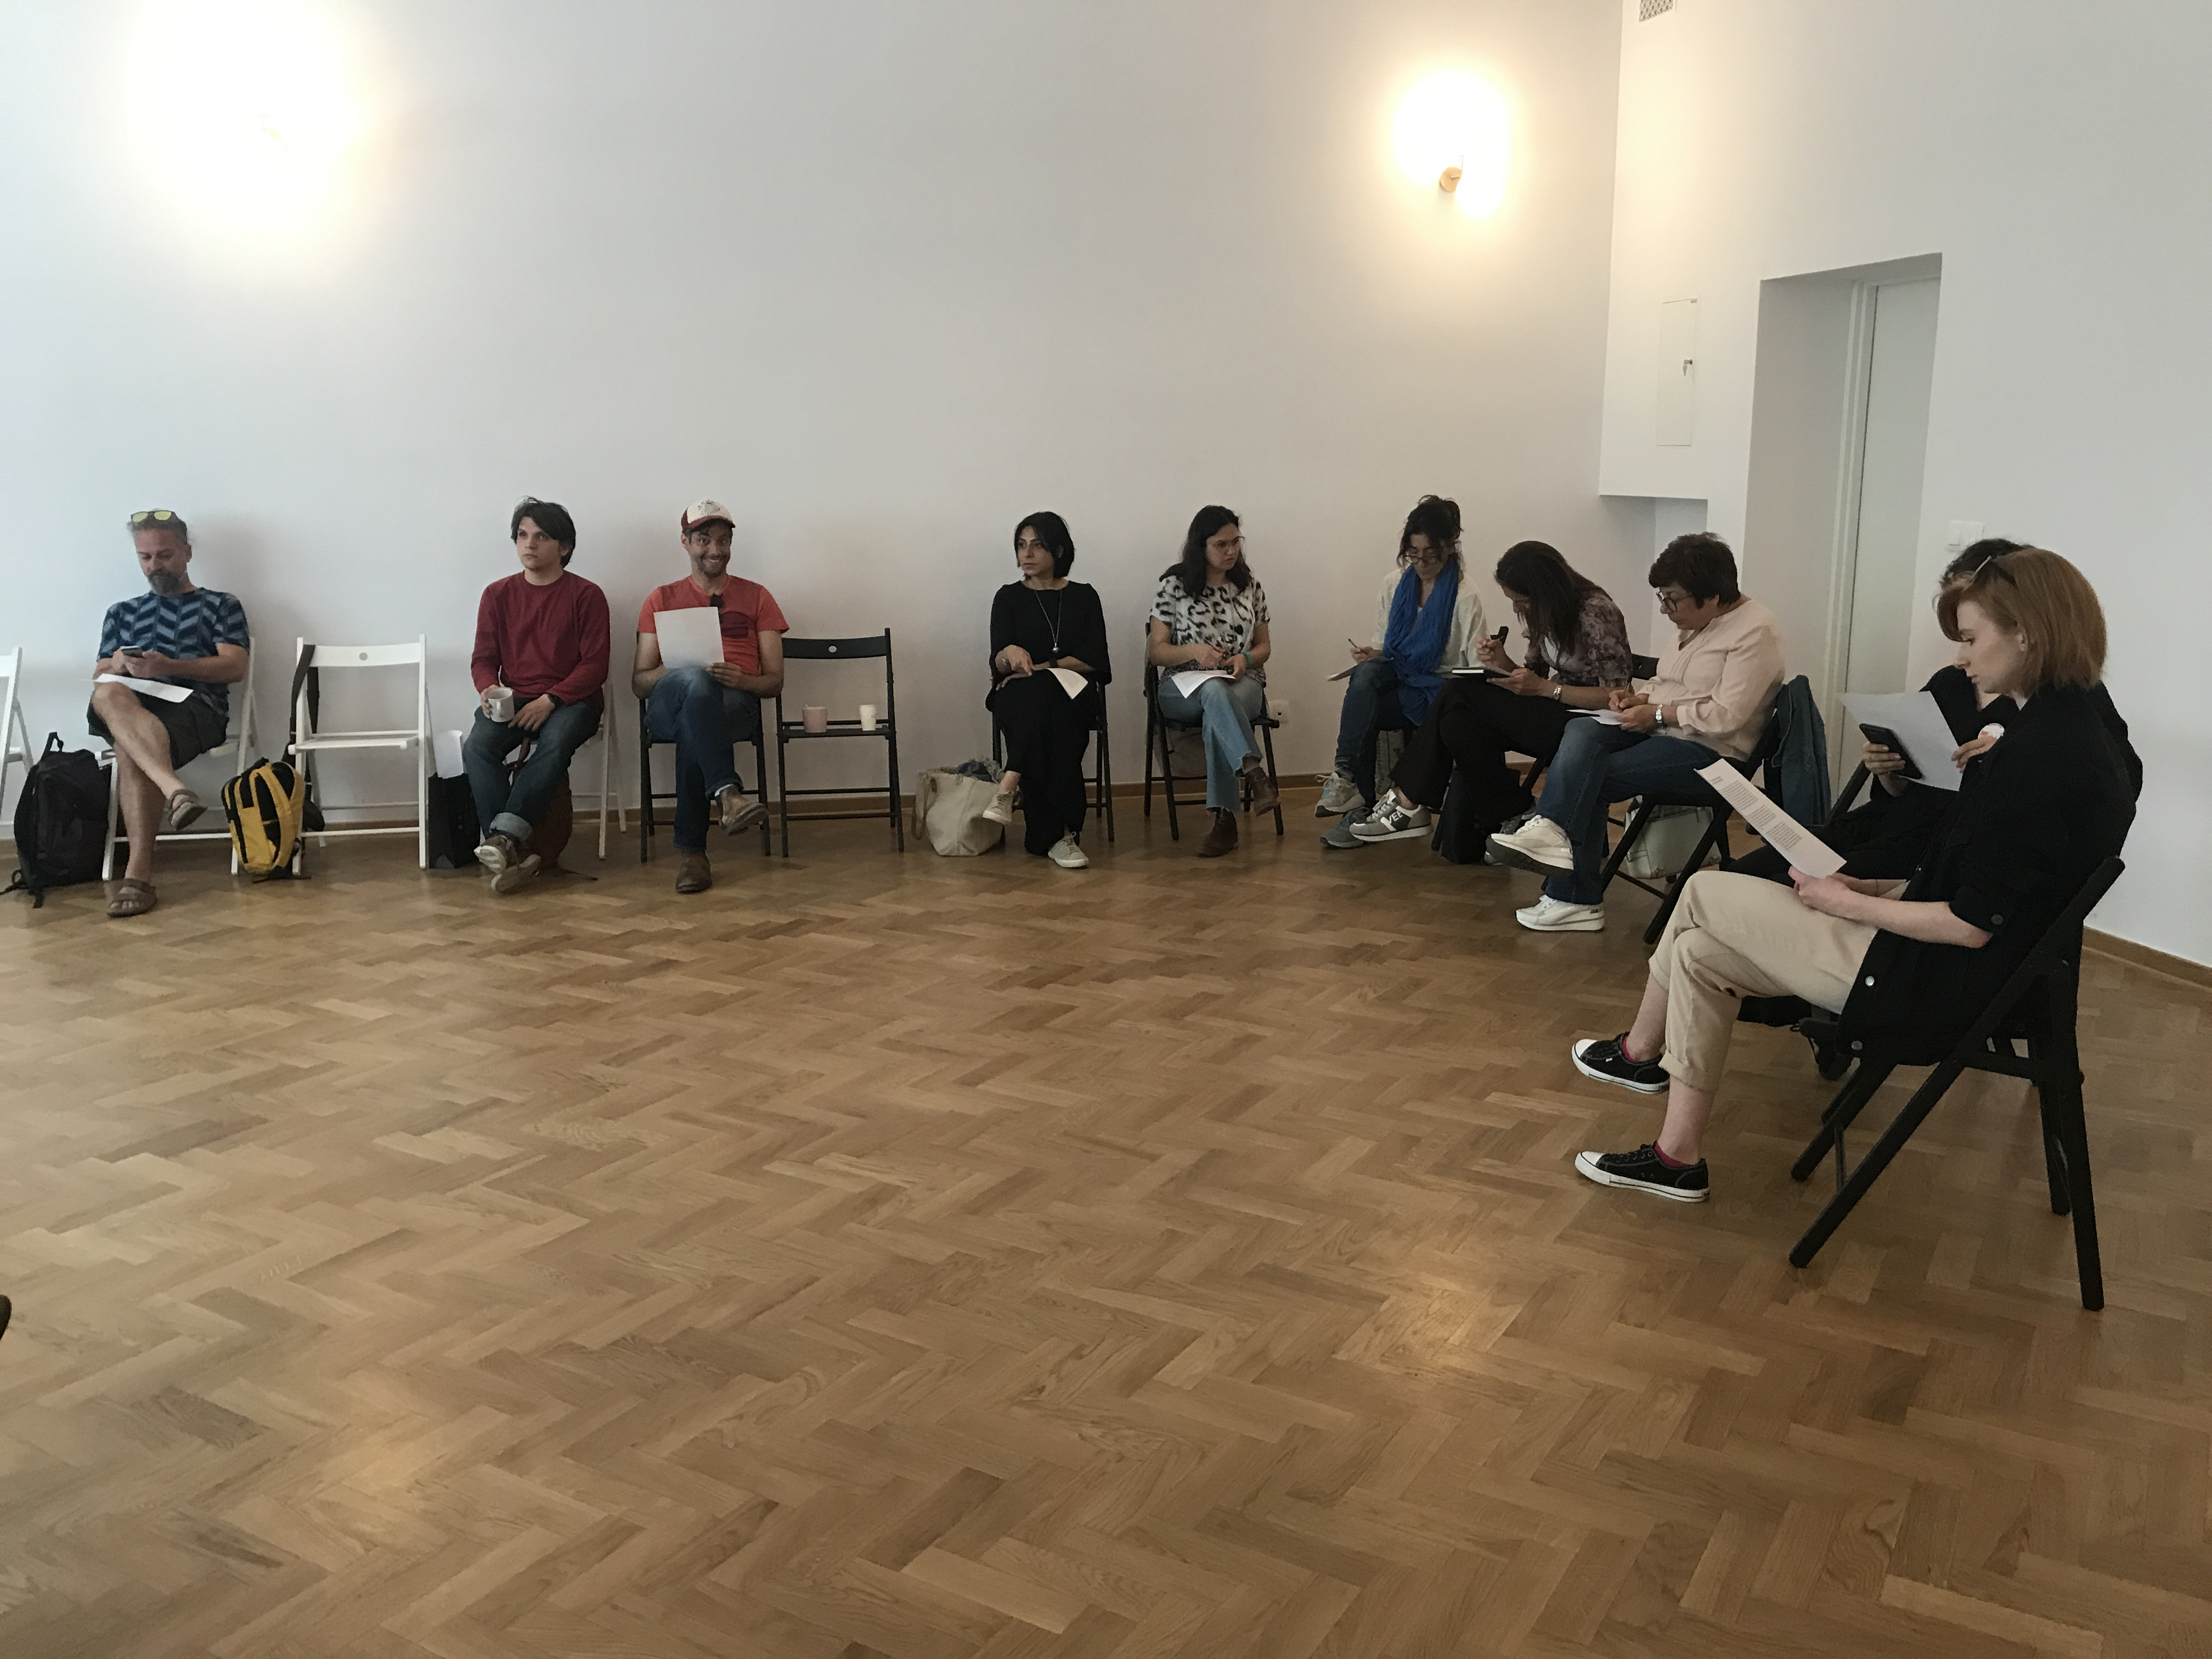
Fourth meeting in Lodz. Focused and creative period focused on following the track, sharperning of tools, immersion, creation, production, testing.
Discovery:
- Creation is play is creation. That is the basic of creative process.
- Creation is (should be) based both on the fantasy of the creator and the viewer/recipient.

- RESOLUTION

Resolution completes the story.

Fifth meeting in Palermo. Presentations of outcomes. What can be expected? Emergence, output, reflection, feedback…

How to wrap up? What are the most valuable outcomes? Reflecting an imaginary stage of the DEPART project, we can use very inspirational thoughts and principles of another theatre giant Bertold Brecht. Let us, only for a while, replace “theatre” for an “online product”:
- Theatre/online product is an entertaining school of critical thinking.
- It is a space for the viewer's comment.
- There should be multiple plans: the actor portrays a dramatic character in its dramatic line, but at the same time deviates from that line - comments, adds a new point of view, asks questions, etc. Such principle is called alienation and allows a dialogue between the actor and the audience.
- Basic principle of theatre is active audience. Spectator should be a co-creator, not just a passive recipient, thus a mere consumer.

In conclusion, it remains to state that although during the course of the project it may not have been possible to create a "perfect" online product, the project enabled research and reflection leading to a clearer view and naming of needs for setting up conditions and creation of a meaningful online product.

